**Sales Performance**

> Year <- c("January","February","March","April","May","June","July","August","September","October","November","December")

> year_ts <- ts(Year)

> internet_Sales <- c(1036,456,741,561,361,801,342,456,1674,647,298,457)

> Sales_in_Person <- c(345,263,400,913,864,210,278,1347,581,245,567,421)

> Sales_via_Phones <- c(691,526,666,211,464,425,786,304,550,144,201,222)

> sales_data <- data.frame(Year,internet_Sales,Sales_in_Person,Sales_via_Phones)

> sales_data_ts <- ts(sales_data)

> hist(sales_data_ts)

> hist(sales_data_ts)

> Jan = 1036+345+691

> feb =456+263+526

> mar=741+400+66

> apr=561+913+211

> Mar=741+400+666

> May=361+864+464

> June=801+210+425

> Jul=342+278+786

> aug=456+1347+304

> sep=1674+581+550

> oct=647+245+144

> nov=298+567+201

> dec=457+421+222

>

> cat(Jan,feb,apr,Mar,Jul,June,aug,sep,oct,nov,dec)

2072 1245 1685 1807 1406 1436 2107 2805 1036 1066 1100

> best_worst_data <- data.frame(Jan,feb,Mar,apr,May,June,Jul,aug,sep,oct,nov,dec)

> best_worst_data_ts <- ts(best_worst_data)

> barplot(best_worst_data_ts,xlab = "month",ylab = "Performance",main = "Best and Worst performance")

> pie(internet_Sales,year_ts)

**Grouped bar chart for the following table**

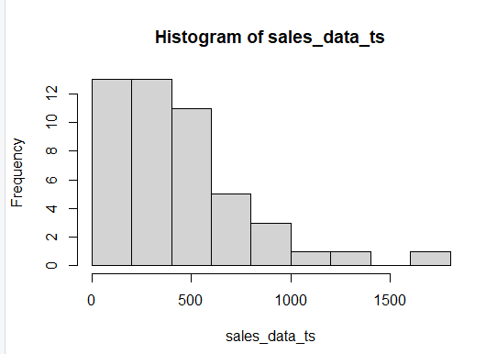

**The best performing month from chart**

**The worst performing month from chart**

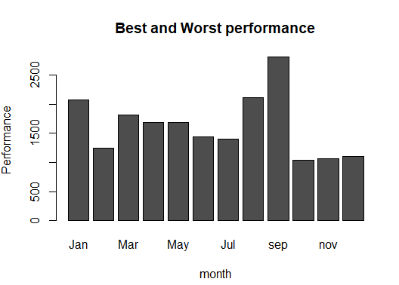

**Month did sales via internet performed better**

